**Bug Title**: Unable to search numeric value.

**Created by:** Komang Sri Aryati

**Created on:** 18 July 2016

**Detail**:

|  |  |  |  |  |
| --- | --- | --- | --- | --- |
| **No** | **Step** | **Expected Result** | **Result** | **Actual Result** |
| 1 | Open browser "Firefox" | New browser opened | **Passed** |  |
| 2 | Open URL "http://automationpractice.com/" | Target URL is opened with title "MyStore" | **Passed** |  |
| 3 | Type in search text field 16 **Note :** there is item that have price 16 | search text is filled with string "**casual**" | **Passed** |  |
| 4 | Click on the search button | All items that have price containing 16 is displayed and **"No results were found for your search"** message does not displayed | **Failed** | **"No results were found for your search"** displayed |
| 5 | Close browser | Browser is closed | **Passed** |  |

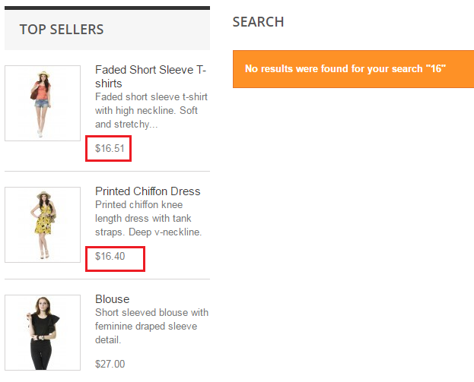

**Priority**: Low; **Severity**: Medium

**Description**:   
Search numeric value is used to filter product that has specified price. So, user could retrieve which item that fit with his/her budget. This issue need to be fixed since there is no menu for ordering / filtering by price.